Project Charter

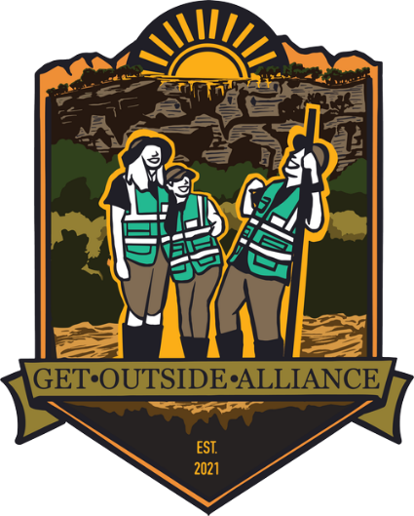

Volunteer Data Dashboard and Database

Sami Elshafie

Charaf Lachouri

Kevin Maldonado

Tatiana Uklist

Tanner Waggoner

2/15/2023

Version 1.3

Table of Contents

1.0 Project Overview...................................................................................3

1.1 Problem Statement................................................................................3

1.2 Project Description................................................................................3

1.3 Project Goals.........................................................................................3

1.4 Project Objectives..................................................................................4

1.5 Project Stakeholders..............................................................................4

1.6 Project Requirements............................................................................5

1.7 Project Deliverables...............................................................................5

1.8 Project Milestones.................................................................................5

2.0 Project Organization..............................................................................5

2.1 Project Manager....................................................................................6

2.2 Project Team.........................................................................................6

3.0 Project Approvals..................................................................................6

1.0 Project Overview

1.1 Problem Statement:

Get Outside Alliance is a nonprofit organization that aims to build advocates for the parks within the Texas Park and Wildlife Department through impactful volunteer opportunities.

Currently, the Get Outside Alliance team is composed of three Houston-based volunteer founders with little expertise, time, or resources to develop tools that will in turn provide them with the in-depth data that they need in order to identify and recruit volunteers. Without the tools, the Get Outside Alliance team would not be able to scale and continue to create advocates for the Texas State Park and Wildlife System.

1.2 Project Description:

Given the problem at hand, the Get Outside Alliance (GOA) team has requested our group’s services to design, develop and implement a dashboard that helps them identify and recruit volunteers eager to be more involved with the Texas State Park system.

There will be two primary focuses for this project. The first point of focus will be to develop a workflow for the GOA team to update volunteer data annually. The datasets are publicly available and contain census data for areas surrounding Texas State Parks. The second point of focus will be on creating analytical dashboards that allow the Get Outside Alliance team to visualize and gather as much category specific volunteer data as they need to get volunteer events fully staffed and therefore create more advocates for the Texas State Park and Wildlife System. Many groups encounter this type of scenario. When you are finished with project what will you leave with the GOA to ensure that they can maintain the dashboard? This is especially important if no on in the group has the technical expertise to add more data or otherwise maintain the dashboard.

1.3 Project Goals:

Our project has two main goals: to create a concise and easy-to-follow, back-end data workflow as well as a practical and easy to use dashboard that allows our clients, the Get Outside Alliance team, to easily understand and use the data on their volunteers.

1.4 Project Objectives

To complete the project and give our clients the best possible product, our project team needs to have the following objectives completed by May 12, 2023. In an ideal world, we could gather data for all 89 State Parks within the Texas State Park system, but the following project objectives are based on the goal of covering all parks within a two-hour drive radius of the Greater Houston Area. In your final report you should indicate why you limited yourself to within a two-hour radius. Also, would this number be better stated in terms of miles?

* Conduct research on how many state parks are within a two-hour drive of the Greater Houston Area to obtain a representative sample of volunteers.
* Gather data on demographics within the two-hour radius of the Greater Houston Area, specifically those that are near state parks to assist in the database maintenance.
* Create documentation (written how-to guide, video instruction) for most self-maintaining visualization software for the Get Outside Alliance team to refer to.
* Create and document the processes needed to complete the project – do you mean complete the project by extending beyond the 120-mile radius?

1.5 Project Stakeholders

|  |  |
| --- | --- |
| **Stakeholder** | **Role** |
| Spencer Frith | Project Client – Spencer is one of the founders of the Get Outside Alliance. He serves as main point contact for the Get Outside Alliance team. |
| Alma Frith --------------------------------------- | Project Client – Alma is the second founder of the Get Outside Alliance. She serves as a secondary point of contact for the Get Outside Alliance team. Alma will also maintain the visualization for whenever the data needs to be updated. |
| Varunya Limtrakul | Project Client – Varunya is the third founder of the Get Outside Alliance. |
| Joseph Sample | Project Sponsor – TCOM 5340 professor |

1.6 Project Requirements

The project team must provide dynamic visualizations and workflow processes and dashboard maintenance documentation to meet the objectives listed above by May 12, 2023. The data must be current and organized. The visualization must be clean, organized, appealing and easy to follow. The workflow process and maintenance documentation must be easy to follow and organized. The project must be conducted at no cost to the client or stakeholder(s).

This section would be better stated as client project requirements. What specific things has the client asked for? Does your client expect to meet with you weekly, for example? Does your client expect you to show drafts, or share your work with others in the organization? Does the client have expectations regarding software or the use of logos or style guides?

1.7 Project Deliverables

We will deliver a dashboard with data and visuals to the Get Outside Alliance. Accompanying the dashboard will be in-depth documentation on workflow processes and dashboard maintenance.

1.8 Project Milestones

|  |  |
| --- | --- |
| **Milestone** | **Est. Date** |
| Project plan submitted | March 29 |
| List of State Parks compiled and approved by client | April 7 What is all this white space doing for you? Nothing. Move the line. |
| Visualization software decided on | April 12 |
| Data visualization built | April 30 |
| Final documentation completed | May 12 |

2.0 Project Organization

2.1 Project Manager

Tatiana Uklist will fulfill duties as project manager for the project. She will also be the main point of contact for the client and help document and develop processes.

Do not use the space bar or the enter key to format. That will allow you to avoid big gaps of white space such as this one. Instead, use “Insert>Page Break to format

2.2 Team Members

Charaf Lachouri will gather data and create visualizations.

Kevin Maldonado will research and decide software to use for the dashboard. He will also help clean-up data create visuals.

Sami Elshafie will gather data, create visuals, and automate data workflows in the dashboard.

Tanner Waggoner will gather data, create visuals, and automate workflows. He will also document workflows and guides for the clients.

3.0 Approval

The undersigned acknowledge they have reviewed the project charter and authorized the Get Outside Alliance Database and Dashboard project. We will coordinate changes to this project charter with and approved by the undersigned or their designated representatives.